|  |  |
| --- | --- |
| Date : | 7/4/2017 |
| Present: | Alexis, Maggie, Percy, Tyler |
| Apologies: | None |

Minutes

1. Project Idea

Everyone agreed on making a Habit Manager App

Still need to agree on name.

1. Core Functionality

Core functionality will be the creation and use of “sessions”.

Each session is a customizable timer that can be created, turned on/ off, edited and deleted. At the end of each timer the phone plays a ringtone or vibrates.

Aim to make the sessions work first, before making any other functionality.

Tyler mentioned need for tutorial to show user how to use sessions. May be able to make a template session to show user what they can make.

1. Ideas for Extended Functionality

Habit manager should be able to add other habits that don’t neccesarily require a customizable timer.

Examples of habits:

* exercise
* brushing teeth/ hygiene habits
* medication/ drugs
* drinking water
* eating healthy
* meditation
* music practice.

Some habits done daily, some down weekly.

We can make it so you can pick which days the habit reminds you on, daily ones can tick everyday.

e.g. stolen from windows

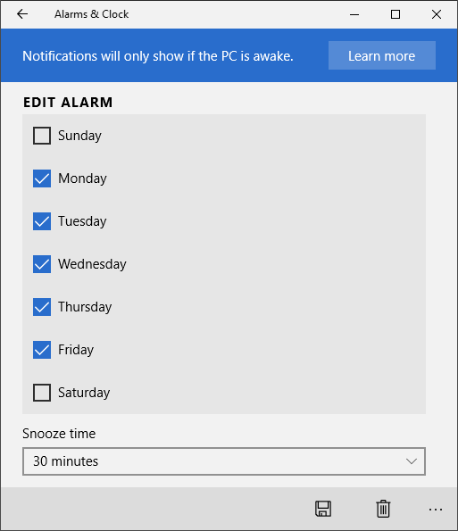

Sessions can be included with daily reminders on main page of interface.

Each day of the week gives you a to do list with habits listed for that day. Need to update for each day.

1. Super Cool Extended Functionality

GPS location reminders

* when you get to a place you normally do the habit it , the app could ask you or remind you to do an activity.
* User can pick location of area.

Doze/ Motion Sensing

* Auto detect if standing or sitting to use with the office working breaks habit.

Siri/ Voice activation

* use siri to set timers, make new habits etc

Apple health support

* Interface with other apps to monitor habits.

1. User interface Design

Want a draft design of the user interface in the report. – Maggie to prepare.

Richard said everything we want the user to be able to do has to be expressed I the user interface somehow.

Main Page

* has habits and sessions for the day of the week.
* Can go to edit page
* Can create new habit page
* Editing can be done by long press down on the habit

New habit page

* Set name, days etc for habit.
* If session can have link to customize timer page

Customise timer page

-can pick length of work and break blocks

- size of blocks depends on length of time specified.

- whether or not too loop or stop at end etc.